DCCD member management manual

Member management in DCCD involves the activation and deletion of DCCD members (users of the website). For doing member management you need a DCCD account with ‘admin’ privileges. Having this privilege also allows you to edit all the members and organizations’ detailed information and the editing itself is the same as for normal members on their own information.

DCCD has a special member with ‘admin’ privileges, whose login name is ‘dccduseradmin’.

When logged in as privileged ‘admin’ member the site will show more options then when logged in as a ‘normal’ member. The most important pages for member management are obviously the ‘Members’ page and pages linked from there.

After login into the system, use the ‘Members’ link from the top menu.

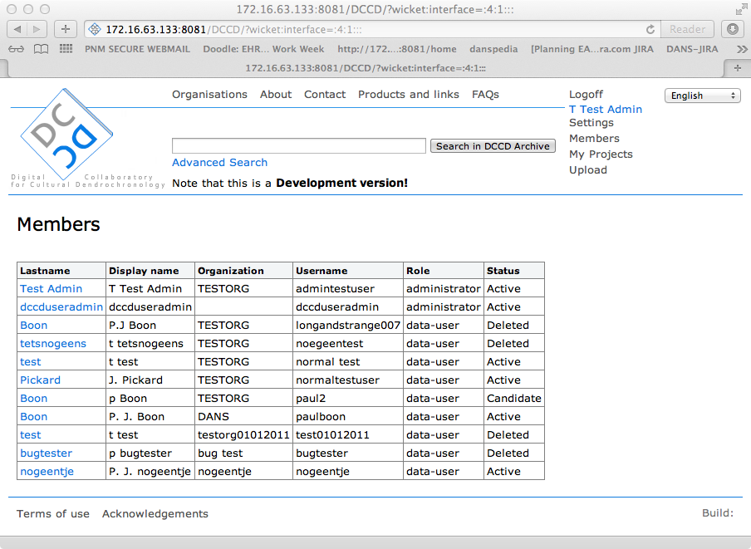

This page gives an overview of all registered members in the order of their registration, so most recent registered members are at the bottom. When clicking the member’s link (in Lastname column) you go to the details page of that specific member.

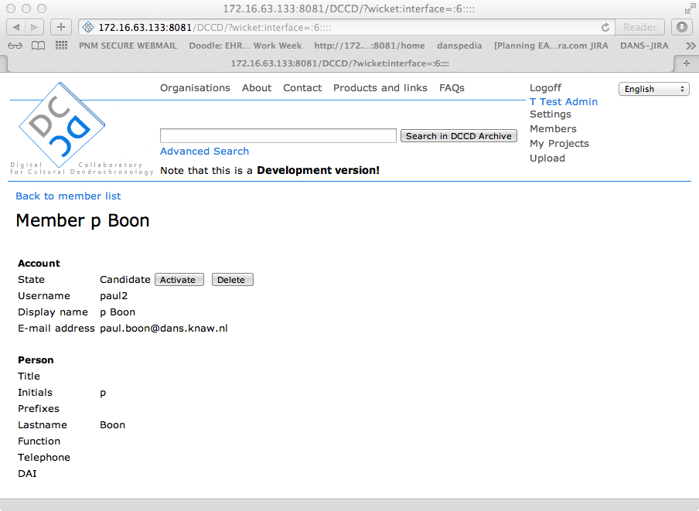

## Activating a candidate member

When a member has registered, the status of the account will be ‘Candidate’ and the member cannot login into the system. When membership has been approved the member needs to be activated by clicking the ‘Activate’ button on the member’s details page. If the member has also registered a new organization, there will be a dialog box popping up and asking for confirmation. Just click ‘OK’ to continue.

On the ‘Contact member ‘ page a default mail message is shown, which you can edit if needed. To continue activation and send the activation message to the member push the ‘Send’ button.

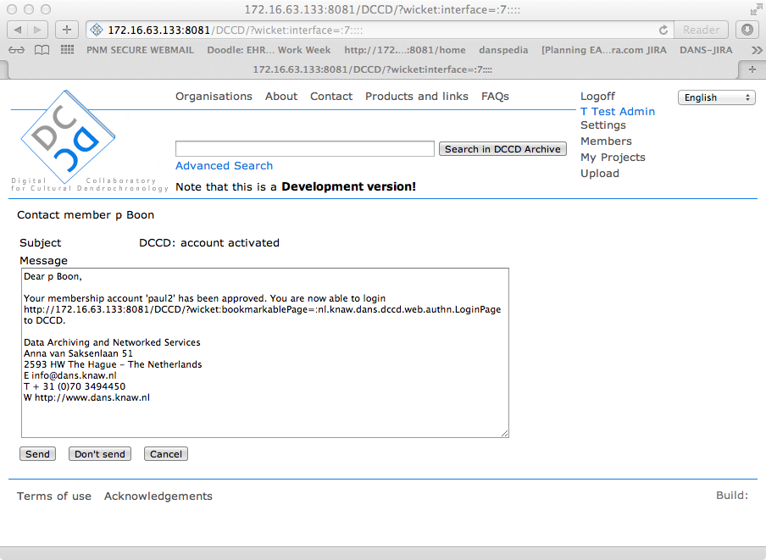

If you browse to the Members page you would see that the member in question now has the ‘Active’ status.

### Member activation after receiving a notification mail of the registration

When a member finished the registration, the resulting candidate member account will be added to the DCCD system and a notification mail message is sent to the mail address of the ‘dccduseradmin’ . The administrator will receive a mail message containing the information about the newly registered member and a link to activate that member. When the link in the mail is clicked the browser will go to the members Settings page via the login screen, so after logging in the administrator can click on the ‘Activate’ button as describes previously.

## Deleting a member

When deleting a member the account information is not removed from the system, but the account is ‘deactivated’ so the member cannot login anymore.

Deleting is similar to activation; just push the ‘Delete’ button on the member details page.

Note that a deleted member can be reactivated if needed and a candidate member can be deleted as well.